Ian Baillie Grade Two 2015-2016
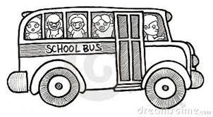
Dear Grade Two Parents,
I am collecting a $35.00 fee to purchase classroom supplies for your child. Some items I had requested in the past were very specific and parents had difficulty finding them. Therefore, let me do the shopping! All you need to do is send in $35.00 at your earliest convenience. This fee will cover all your child’s classroom supplies for the year. Receipts will be issued.
Your child will also need the following items but are not included in the fee. I ask you to purchase them on your own.
1. A book bag
2. A lunch bag
3. 3 boxes of facial tissue (Kleenex)
4. Ziplock bags (1 large box, 1 medium box)
5. A pair of sneakers to remain at school
6. A change of clothes (please write your child’s name on each item)
I am looking forward to meeting you and your child. See you in September!

Grade Two Teachers

