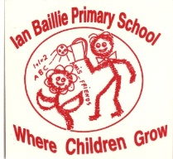
Ian Baillie Primary School
______________________________________________________________________
78 Henderson Street, Unit 2 . Miramichi New Brunswick E1N 2R7
Telephone: (506) 778-6076 . Fax (506) 778-6533

Memo
Helping an Ian Baillie Family
Beth McCarthy

Yesterday at approximately four o’clock one of our families from Ian Baillie tragically lost their house in a fire. They were left with only the clothes they were wearing. We would like to reach out to this family by asking the families of Ian Baillie to make a donation to help them purchase clothing, groceries and whatever else they need to get back on their feet. You can send the donation to the school in an envelope and we will ensure that they get it. As always, we have the greatest most generous parents at Ian Baillie and I thank you in advance for your help with this.

As well, Tricia McNeil would like to do a 50/50 draw to help this family. You will see tickets coming home with your child over the next few days.

Some people have asked what sizes the children wear. One of the boys takes a size 9/10 and the other takes a size 6/7. The mom size is between a 2/3 or a 4/5. Once again, thank you for everything.

